Tips for improving access to SUT data

You will only see lines or columns for which data are available. Therefore, a table could be shorter or larger according to countries or years selected, even if selections of other dimensions are identical.

As SUT are very large, we advise you to modify your selection in the “Overview” mode and then go the “Table” mode. If you modify them directly in the “Table” mode, your changes will be executed one by one and therefore it will take longer.

On the “Filters” part, on your left, if there is no indication of the number of elements selected, this means that all elements are selected. For example, below all elements are selected for Transaction, while only one Time period and one Reference area are selected.

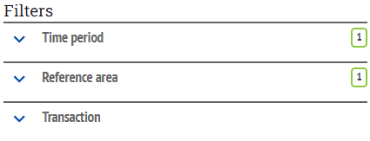

To modify the content of any element of the “Filters” part you can select or deselect items one by one or use the advance selection modes which are accessible by clicking on icon of selected filter.

If you want to select all elements of a filter, we advise you to click on icon  and then on “Deselect All” rather than “Select All”.



In this way, you will always have all details available regardless elements selected in the other filters. Whereas with “Select All” you only select all available items for those elements that are currently selected in the other filters.

This will make a difference when you move from a country with less detailed SUT to one with full detailed SUT. With “Deselect All”, your selection will increase to cover all the series available for the new country, whereas with “Select All” your selection will be maintained to the level of details available for the first country.

If you wish to select transactions that are not broken down by activity, such as household final consumption expenditure, you must select the ‘Not applicable’ item in the “Economic activity” filter. Otherwise, these transactions will be greyed out and cannot be selected.

Due to Explorer's limited data points, if you require the most detailed level for product and economic activities, it is only possible to extract SUTs for one year and one country at a time. If you only need the first level of product and economic activity classification (which is the default view, you'll be able to extract SUTs for a greater number of countries and/or years.

If your applied filters list is very long, a part could be hidden. If you want to extend it, please click on the “V” sign before “Applied filter”.

The “Chart” mode is useful for SUT only if you select a small number of time series.